# 

**Chandigarh Group of Colleges,**

**Jhanjeri, Mohali - 140307**

**Department of Computer Science & Engineering**

**Live Logging Attendance System**

Project – II

**BACHELOR OF TECHNOLOGY**

(Computer Science and Engineering)



**SUBMITTED BY :**

Name Roll No.

Prerna Sharma 1816589

Abhinandan Kumar 1816823

Prince kumar 1816590

AUG 2021

**Under the Guidance of**

Ms. Sakshi Sharma

Prof. Software Engineering

**Department of Computer Science & Engineering**

**Chandigarh Group of Colleges**

**Jhanjeri, Mohali - 140307**



**Chandigarh Group of Colleges,**

**Jhanjeri, Mohali - 140307**

**Department of Computer Science & Engineering**

**Table of Contents**

|  |  |  |
| --- | --- | --- |
| **Sl. No.** | **Contents** | **Page No.** |
| 1. | Introduction | 03 |
| 2. | Brief Literature Survey | 04 |
| 3. | Problem formulation | 05 |
| 4. | Objectives | 06 |
| 5. | Methodology/Planning of work | 10 |
| 6. | Facilities required for proporsed work | 13 |
| 7. | References | 14 |



**Chandigarh Group of Colleges,**

**Jhanjeri, Mohali - 140307**

**Department of Computer Science & Engineering**

**Introduction**

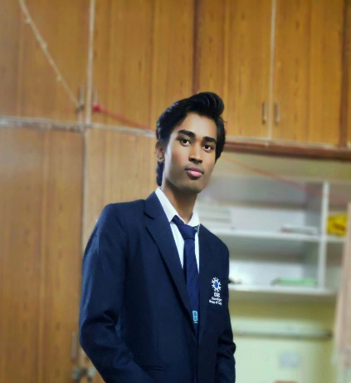This project is based on the technology of Machine Learning and AI, it marking attendance from detecting faces of persons. It detects the face of person in real time using webcam. The Machine Learning techniques we use in this project is image analysis, face detection, face recognition and computer vision.

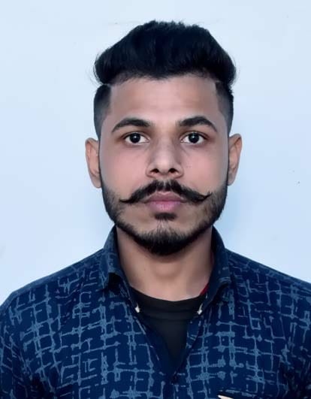

**Persons, they want to mark their attendance**

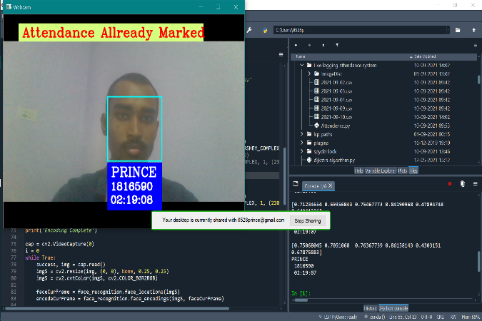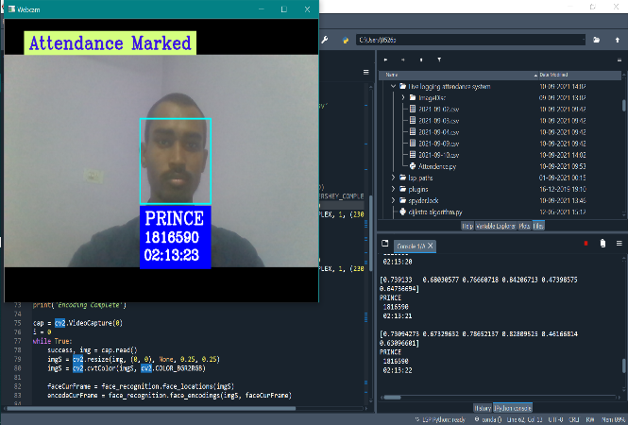

**Marking Attendance**

This Model is checks that captured image attendance is marked or not and take the decision based on the data which it will be get, processed it and give the output. If the attendance of that capture image is not marked then model mark it. If the attendance of that captured image is already marked then the model shows attendance already marked of that captured person image. So, we can proceed it to the next one and same process is repeated for the every person.



**Chandigarh Group of Colleges,**

**Jhanjeri, Mohali - 140307**

**Department of Computer Science & Engineering**

**Brief Literature Survey**

From a long term we use the old method for taking attendance using paper or pen. One by one we call the roll no or name of student and then we mark it present or absent. We also uses many papers or pages for store the data of attendance. And also teachers facing many problems while taking attendance. Sometimes due to miscommunication teacher mark the wrong attendance.

For store the data of attendance we use lot of papers. So, we have to cut a large amount of tree in whole world for accruing the demand of papers. According to the survey a single tree produces 10,000 to 20,000 papers.

Papermaking has an impact on environment because it destroys trees continuously in every single day. According to the data from the Global Forest Resource Assessment roughly 80,000 to 160,000 trees are cut down each day around the world for papermaking by the paper industry.

So we are made a digital method to mark attendance of peoples without using pen and paper. Therefore, we are work productively and comfortably.

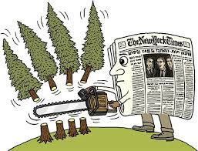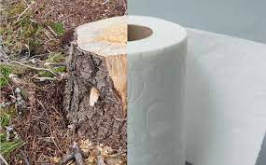

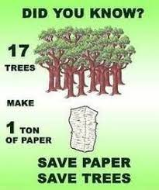



**Chandigarh Group of Colleges,**

**Jhanjeri, Mohali - 140307**

**Department of Computer Science & Engineering**

**Problem Formulation**

We are made a programing model which identify the human faces in the webcam in real time. Simply, video file which is the collection of images in the video frame. Using face recognition identify the human faces in the video frame by frame. But we are not work on the whole body of human images. First we select the area of human images where we interested which is called the region of interest (ROI). Rest of the process is listed below :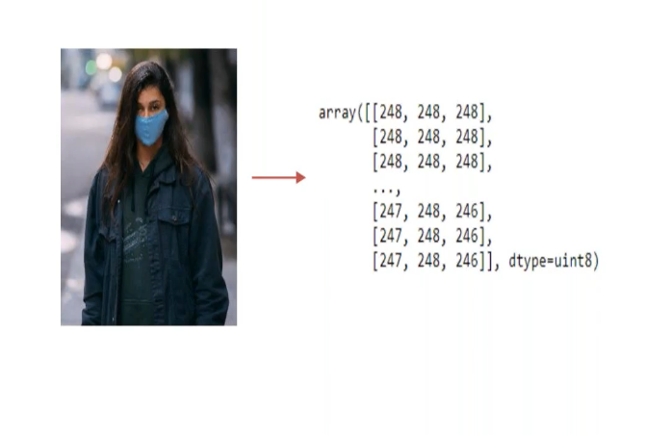

**Loading Image Data**

* The model starts from the loading image data.
* The data could either be an image or a video.
* 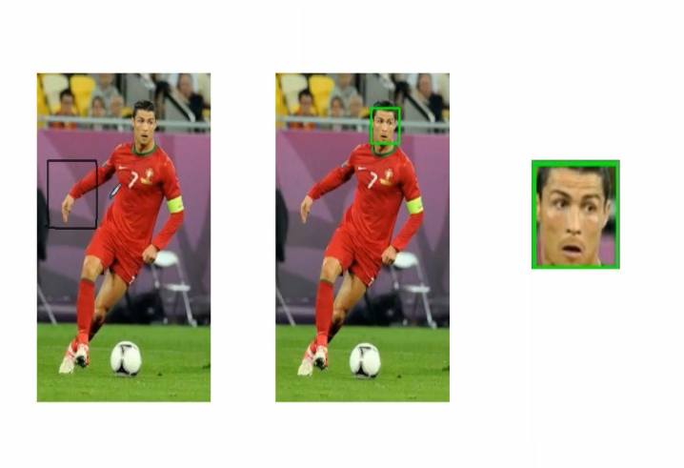In case of a video, the computer reads it frame by frame, which is nothing but images from the video.

**Feature Detection**

* We will detect features like face, nose, eyes, etc.
* Extract a region of interest from the image.

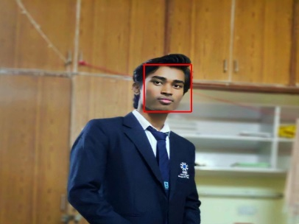

**Encode Face patterns**

* We extract the faces from the images for those person which we want to compare faces and encode it.

**Video Streaming & Real Time Face Detection**

* The idea is use the webcam of the computer
* The video stream will start using Open CV
* While the stream goes on, the feature detection must take place simultaneously
* Encode the faces which extract form the video frame and compare both faces.
* 

**Chandigarh Group of Colleges,**

**Jhanjeri, Mohali - 140307**

**Department of Computer Science & Engineering**

**Objectives**

The goal of this project is to detect and locate human faces in webcam and encode it compare the images which are present in the student or specific directory. We need to make a directory of images where all the images of those student or persons are present which one I want to mark attendance. A set of images were provided for this purpose. The objective was to design and implement a face detector that will detect human faces in webcam similar to the images present in the directory. Where the model compare both images and mark attendance for more accurate input images. If the attendance is not marked, then attendance of particular person is marked. On the other side if the attendance is already marked then it do not overwrite it. All the datas of attendace system is mark automatically and maintaine the csv sheet automatically by the model. We do not need to care about that what will be going on the backend. Perosns only work to show his/her faces in the webcam.

Face recognition uses the technology of Computer Vision and uses techniques of image processing and deep learning. The objective of this project is to build a face recognition system, which includes building a face detector to locate the position of a face in an image and a face identification model to recognize whose face it is by matching it to the existing database of faces.







**Chandigarh Group of Colleges,**

**Jhanjeri, Mohali - 140307**

**Department of Computer Science & Engineering**

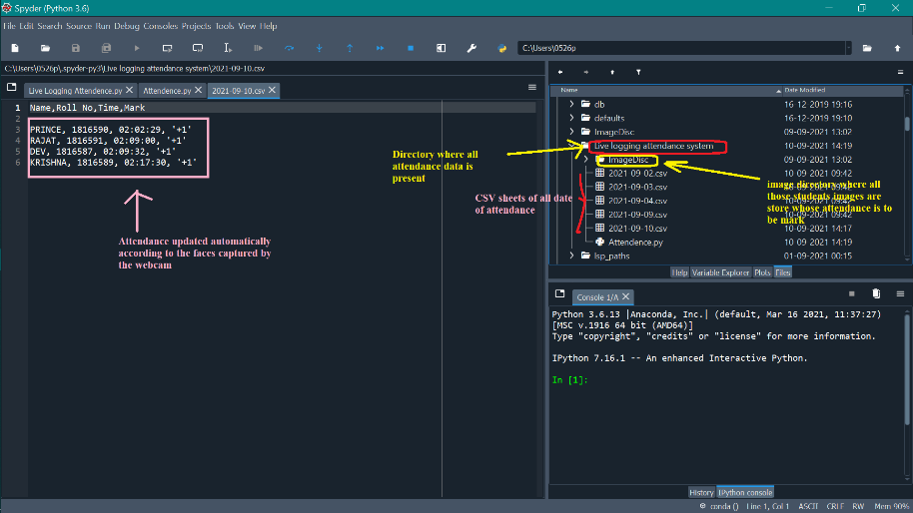

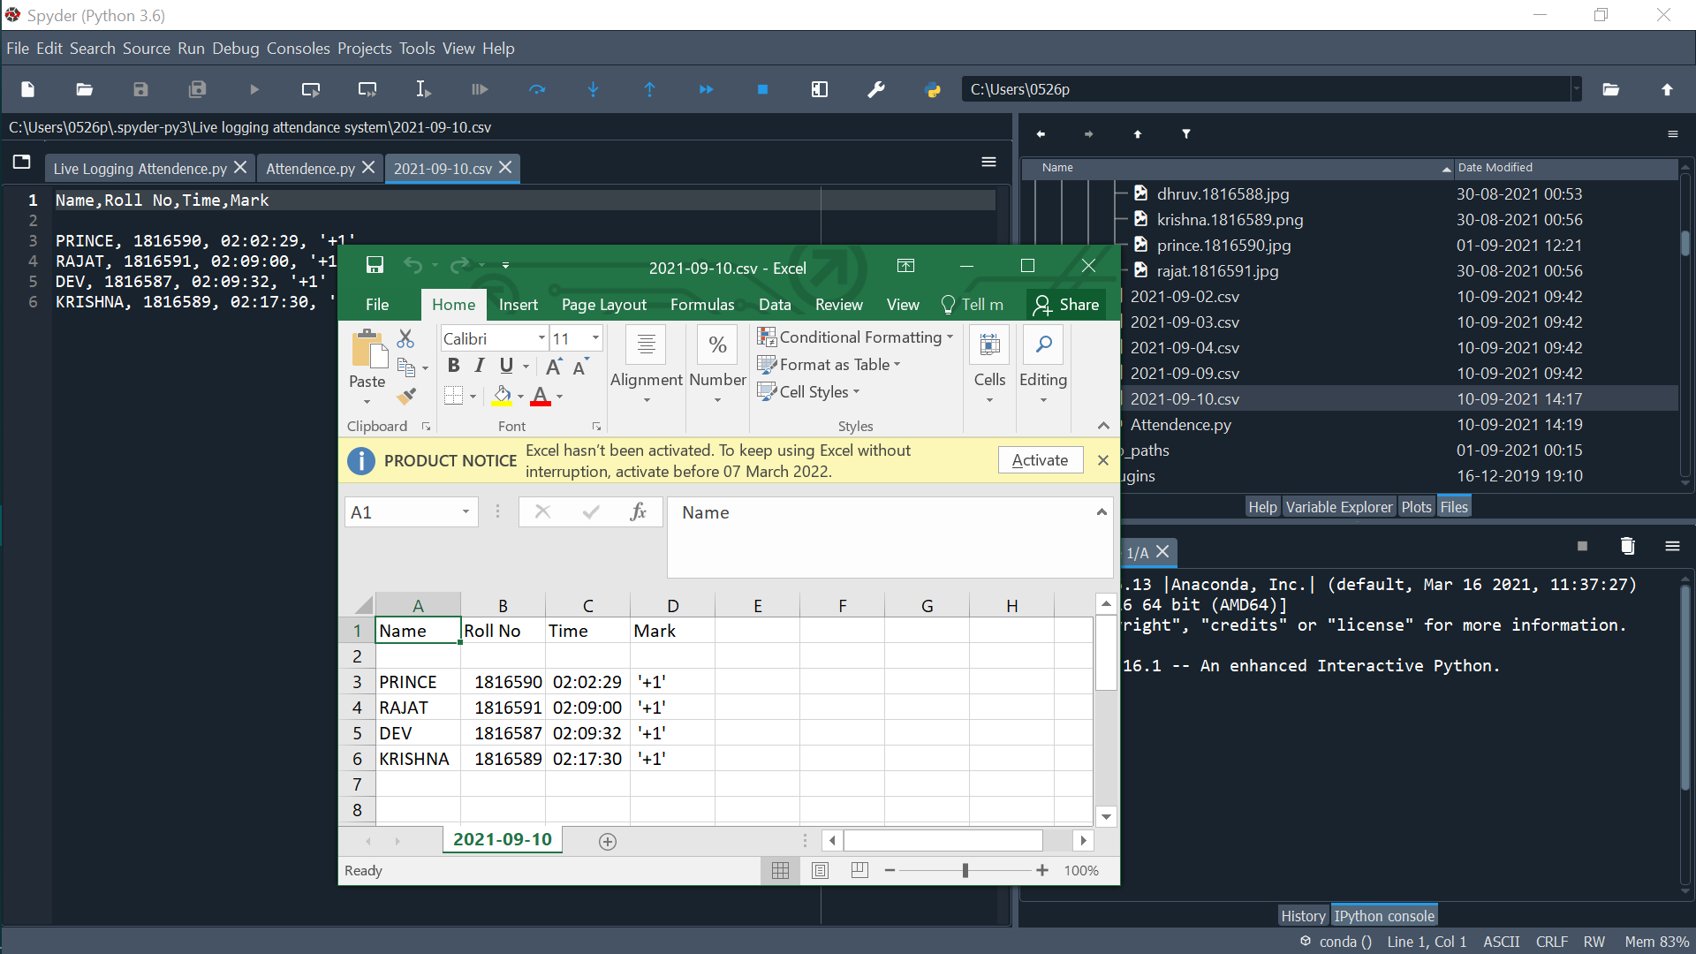



**Chandigarh Group of Colleges,**

**Jhanjeri, Mohali - 140307**

**Department of Computer Science & Engineering**

**Significance**

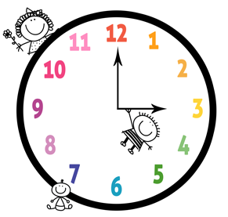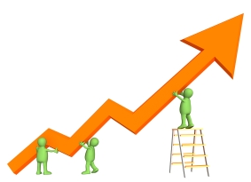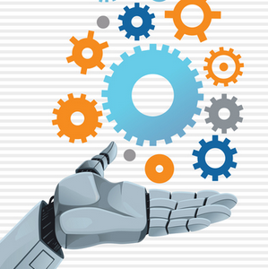



**Chandigarh Group of Colleges,**

**Jhanjeri, Mohali - 140307**

**Department of Computer Science & Engineering**

**Work Flow**

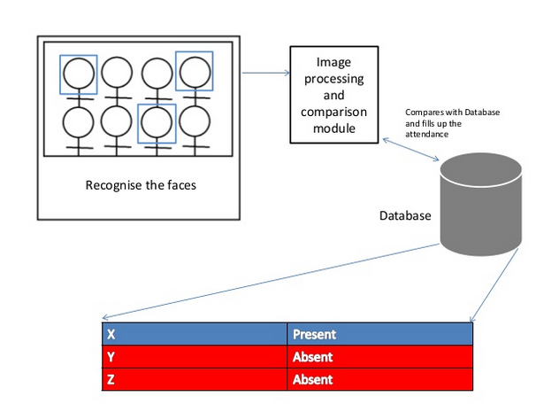



**Chandigarh Group of Colleges,**

**Jhanjeri, Mohali - 140307**

**Department of Computer Science & Engineering**

**Methodology / Planning Of Work**

**Loading Image Data**

1. Method to read image
2. Method to display image
3. Resizing image
4. Video frames

**Encoding of Load Image**

1. Encode all the imges present in the directory
2. Store all the encode list inside the list
3. While use thses encode at the time of compare faces
4. Calculte the face distance of all images present in the directory
5. Lower face distance is the best match and hight face distance is the worst match

**Features Detection**

1. Capture web cam images
2. Using face recognition to extract the ROI
3. ROI(Region Of Interest)

**Video Streaming & Real Times**

1. Method to capture video
2. Looping through the Frames
3. Video Streaming
4. Encode the faces in the current frame
5. Compare the captured face in real time

**Create and Update CSV sheet**

1. Create csv sheet of particular date
2. Update name, roll, time of matched persons
3. Check data sheet if name is already present then it is not overwrite or update again



**Chandigarh Group of Colleges,**

**Jhanjeri, Mohali - 140307**

**Department of Computer Science & Engineering**

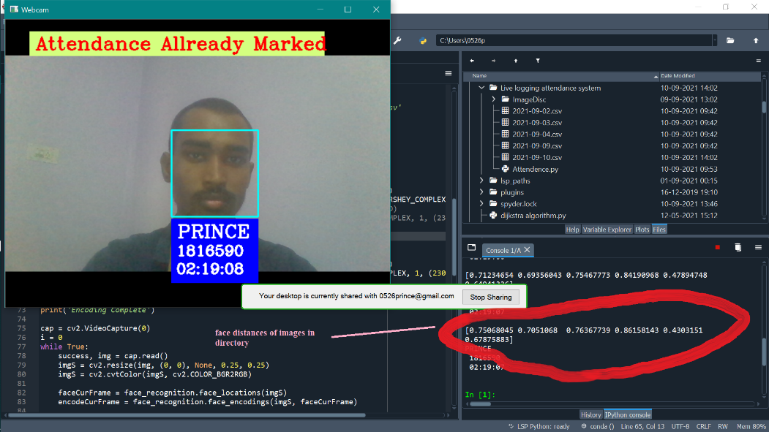

**Compare Faces**

1. Compare faces is a inbuilt function of face recognition which helps to compare the two or more faces
2. After the encoding of faces in the current frame
3. We can compare these encoding of faces to all the encoding of images present in the directory
4. Select the best matches of images

**Face Distances**

1. Face recognition also provides the function which helps to find the face distances of faces
2. According to the compare of faces the best matches faces has min face distances
3. And if the faces is not matched then the face distance is maximum as comparative to the best matches
4. With the help of face distance we predict the name and roll no of captures faces

**Time and Date**

1. We uses datetime library for capture the actual time
2. We grab the actual date and time using datetime function with the help of “.now()”
3. With the help of date we predict, that particular date attendance is marked or not
4. With the help of time we record it which time he enter in the class



**Chandigarh Group of Colleges,**

**Jhanjeri, Mohali - 140307**

**Department of Computer Science & Engineering**

**pytz**

1. We uses pytz library with datetime because there is problem in datetime library it is depend on the source of any device which display time
2. Like if we not use pytz library then it grab the time which is shown in by the cpu or such type of devices
3. Using that library we can grab the locality time such as our locality time is Asia/Kolkata
4. We need to pass the locality which locality time you want to grab



**Chandigarh Group of Colleges,**

**Jhanjeri, Mohali - 140307**

**Department of Computer Science & Engineering**

**Facilities Required For Proposed Work**

**Skills**

1. **Python**: Knowledge of python is first and most compulsory key for making any Machine Learning and AI projects. Must know how and where to uses loop, conditional statements.

1. **Numpy**: It requires for the mathematical calculation which we are not able to do manually.
2. **Open CV2**: For image and video processing we use the cv2 library for read the file directory.
3. **Face Recognition**: Face recognition is use for detecting faces in in the images or in video frames. It contains lots of function such as “encoding” we use it for encode faces from imge or video frames. “face distance” calculate face distance to check the best match “Compare” compare two or more faces using the face encoding if it both face encode is match then it’s face distance is less and vice versa.
4. **Time and Date:** It uses to grab the actual date or time. We are using the library for that purpose for is datetime.
5. **Pytz:** It is uses for grab the Indian standard time Asia/ Kolkata. Without depends on cpu or any other divices time source. It grabs automatically when it will be execute
6. **CSV Files:** It uses to create csv data sheet for mark attendane or update the attendance. We can check it on externally. Or we can also convert into excel files according to their needs and desire.

**IDE**

We uses Spyder (version 5:10:2) or Scientific Spyder, Anaconda for making the Live Logging Attendance System. Personally, I recommend Spyder from Anaconda is the best ide for building models. Besides that you can also work on the ide of google colab, jupyter, pycharm, python 3 and so on. But in all of these ide is some disadvantages and advantages while in spyder gives a lot features for working effectively. You can easily install packages and libraries from anaconda navigator or anaconda prompt.



**Chandigarh Group of Colleges,**

**Jhanjeri, Mohali - 140307**

**Department of Computer Science & Engineering**

**References**

In this project, we have developed a machine learning model for face mask detection using Python, face recognition and OpenCV. We developed the live logging attendance system model for detecting faces and mark attendance of that person whose face are in the current frame. Update CSV sheet according to the data getting from the webcam. If value is already recoded then proceed if not then update it. We have made the model using face recognition. Encode the image of the student in the directoy is the first part of this project and capture faces from webcam using OpenCV and encode the face captured from the current frame is the second part.

We have presented a live logging attendance system with a reasonably good accuracy and running time. The design are tuned for the constrained scene conditions of the training images provided, hurting its robustness.